### Alarm Panels

Often we use smaller panels as a workstation in diverse rooms (especially the smaller cabins and messroom) these panels are called DAP (Duty Alarm Panel). These DAP’s have to be pointed out to the system. Under Alarm Stations>Alarm Panels you can set these DAP’s (see Figure 12‑6).

|  |  |
| --- | --- |
| **Alarm group option** | **Explanation** |
| MAC | Type the MAC-address of the DAP here |
| Alarm Station | Choose which station it will represent (for alarm settings) |
| DAP Type | Choose the type of DAP in use |
| IP | IP address in range 172.xx.0.81 and so on |

*: after changing these settings choose “ accept and restart communication” to activate the changes.*

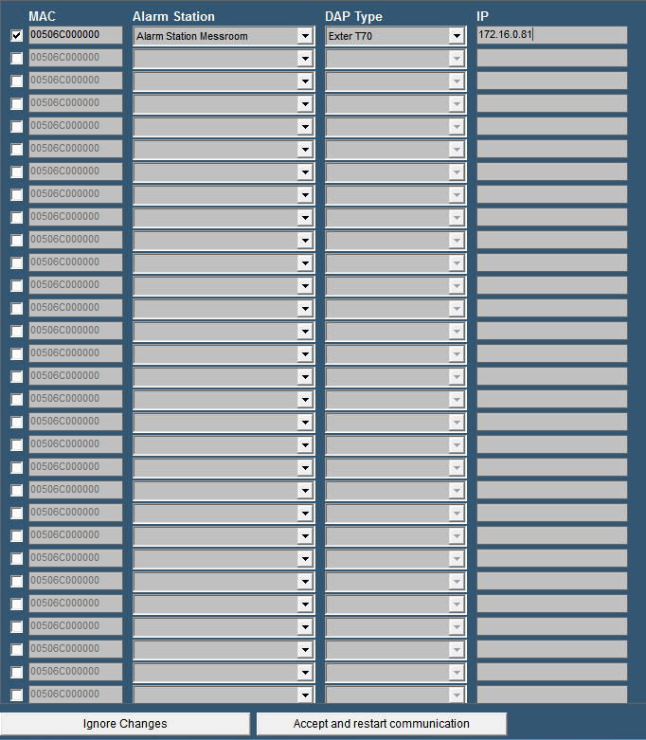

Figure 12‑6: Alarm Panels